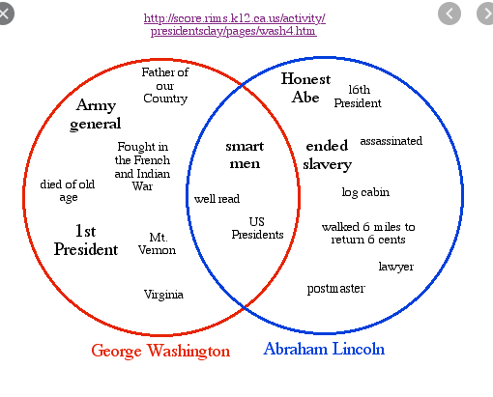
- Washington and Lincoln are similar in the following ways BESIDES:
  - Smart men
  - Well read
  - US Presidents
  - Died of old age

- How did President Lincoln die?
  - Died of old age
  - Assassinated
  - Heart attack
  - Died from a terrible accident/injury

- From the items listed for President Washington, what would you conclude his primary role (job) to be during this time, prior to his presidency?
  - Military man
  - Lawyer
  - Postmaster
  - Realtor

- Which of the following would you infer to be President Lincoln’s nickname?
  - Virginia
  - Lawyer
  - Postmaster
  - Honest Abe

