Indian Life and Adventure

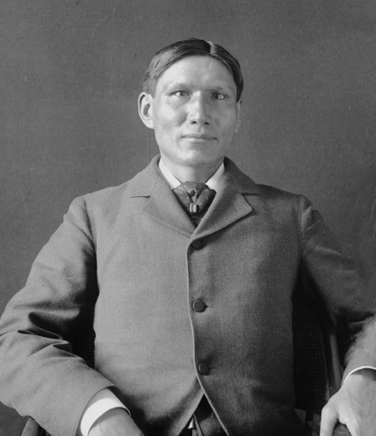
by Ohiye S’a/Charles Alexander Eastman from Indian Boyhood

Ohiye S’a, whose English name was Charles Alexander Eastman, was a Santee Dakota tribal member of Native Americans. A writer and doctor, he was the first to write about tribal life from the Native American viewpoint. Born in Minnesota in 1858, Eastman wrote Indian Boyhood in 1902. It tells about the first fifteen years of his life. Below is a passage from Chapter X of Indian Boyhood.

To me, as a boy, this wilderness was a paradise. It was a land of plenty. To be sure, we did not have any of the luxuries of civilization, but we had every convenience and opportunity and luxury of Nature. We had also the gift of enjoying our good fortune, whatever dangers might lurk about us; and the truth is that we lived in blessed ignorance of any life that was better than our own.

As soon as hunting in the woods began, the customs regulating it were established. The council teepee no longer existed. A hunting bonfire was kindled every morning at day-break, at which each brave must appear and report. The man who failed to do this before the party set out on the day’s hunt was harassed by ridicule.

As a rule, the hunters started before sunrise, and the brave who was announced throughout the camp as the first one to return with a deer on his back, was a man to be envied.

Multiple Choice Quiz

- Why did Eastman compare the wilderness to paradise?
- They were both very hot and far away.
- It was a luxury of nature, not of civilization.
- He often vacationed there with his family.
- It was a place he always wished to visit.

2. What two things occurred once hunting regulations were established?
- Council teepee no longer existed and all wild animals could be hunted
- Council teepee no longer existed and a hunting bonfire was kindled every morning
- All wild animals could be hunted and hunters could kill an unlimited amount of animals
- All wild animals could be hunted and a hunting bonfire was kindled every morning

3. What determined and established “the brave”?
- First one to return with wood on his back
- Last one to return with wood on his back
- First one to return with a deer on his back
- Last one to return with a deer on his back

